What course AI

Vision Document

Name: Kyle Kelly

Supervisor: David Hearne

Table of Contents

Introduction……………………

Business Case Summary………

Business Model Canvas……….

User Descriptions/Goals………

Alternative Solutions………….

Application Overview………...

Application Features………….

Main Risks……………………

References…………………….

**Introduction**

The major goals of the What Course app are outlined in this vision document, together with information on the users, the software, and the significant risks involved in creating this application.

This project's goal is to create a mobile application that will help students better manage and comprehend the courses that are offered to them. The app can also enable course comparison for the students. What topics are addressed in each course, and which one delivers the best results. accessing the course.

Students will be able to use this program to explore and pinpoint the best classes to fulfill their academic and professional goals. We are aware that choosing the best course might be difficult considering the wide range of options provided by various universities and professions. Because of this, our app is designed to provide students with personalized recommendations based on their interests, career objectives, and academic background.

**Business Case Summary**

The education market will be worth $7.8 trillion globally in 2022, making it a multibillion-dollar industry. With a projected market value of $319 billion by 2025, the online education sector is one area of this business that is expanding quickly.

More students are using digital platforms to complete their education remotely as a result of the COVID-19 epidemic, which has expedited the implementation of online learning. Additionally, studies have indicated that 91% of students view technology as being crucial to their educational process.

These patterns suggest that there is a significant market need for educational software that gives students a more interactive and interesting approach to explore their academic possibilities.

. There is a growing need for customized, approachable, and technologically advanced solutions that can assist students in navigating the challenging world of academic and professional options as the education industry continues to develop.

An app that may simplify the course discovery process and make it more accessible to students from all backgrounds is increasingly needed as more students than ever before consider higher education. In this business case, we suggest creating a course application that would give students a way to look up, contrast, and select classes that matched their interests and aspirations

**Business Model Canvas**

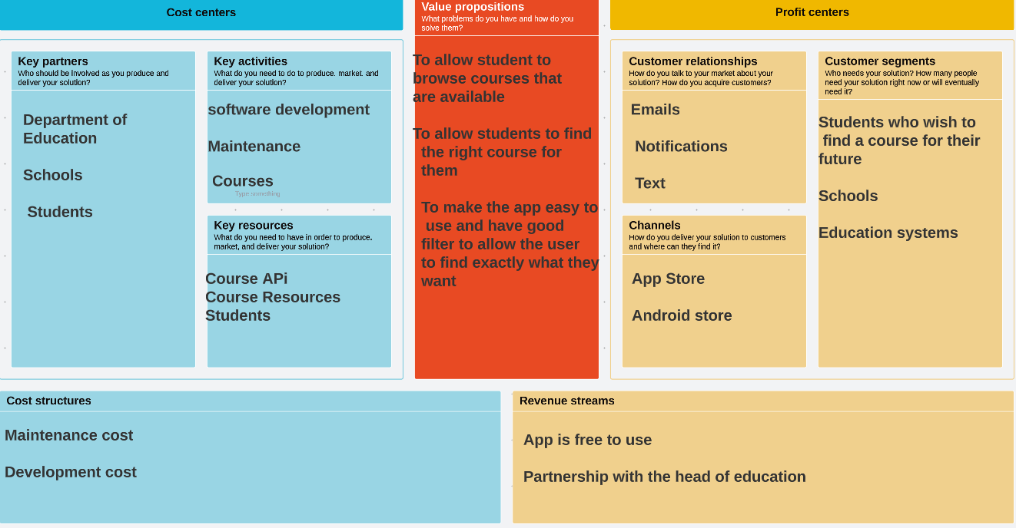

**User Descriptions/ Goals**

* To easily browse through all available courses, sorted by department or subject matter.
* To view detailed information about each course, such as the course description, prerequisites, and schedule.
* To compare courses side-by-side to determine which courses fit best with their academic goals and schedule.
* To receive personalized recommendations for courses based on their academic history and interests.
* To track their progress towards fulfilling degree requirements and academic goals.

**Alternative Solutions**

The alternative solutions that the target users could use are:

Qualifax - This is a website that allows students to browse multiple different courses that are available. They can filter course by points, course length, money amount and many other options.

The thing with qualifax is that they only have a website. They do not have an app, which means there is no competition on the application market.

**Application Overview**

Application that aids students in browsing and investigating the many courses offered at their college. Students can browse for courses using the application's user-friendly design, filter them based on different criteria, and examine specific details about each course.

The application seeks to make choosing courses for students easier and give them the information they need to choose their academic paths wisely.

**Application Features**

* Course Search: The program has a search field where users can type in terms associated with a particular course they are interested in. Students can limit the search results based on a variety of criteria, including department, level, and credit hours. The search results are presented according to relevancy.
* Information about each course, including its description, grade, schedule, and instructors, is displayed in full by the application. To have a better understanding of the course, students can also read evaluations and ratings left by former participants.
* Course Comparison: Using the tool, students may compare several courses side by side, making it simpler for them to see how the courses differ and how they are similar.
* In order to use all of the capabilities of the application, students must first register an account. Students' accounts allow them to save preferences, view search histories, and access wish lists.

**Main Risks**

* Inaccurate or out-of-date course information: The accuracy of the course material shown to students is one of the key risks associated with this application. Students can wind up relying on old or erroneous information if the application doesn't update its course database frequently, which could cause confusion or scheduling difficulties.
* A danger of data breaches or other security problems exists because the application requires students to register in order to access all of its capabilities. Sensitive information like student names, email addresses, or course preferences may be compromised if the program doesn't put in place sufficient security safeguards.
* Technical errors or server outages could make it difficult for students to browse and choose courses if the application encounters these problems. This can make users frustrated and lose faith in the application.

**References**

1. <https://www.qualifax.ie/>
2. <https://www.spaceotechnologies.com/blog/education-app-ideas-for-students/>
3. <https://www.thejournal.ie/advice-parents-college-course-4095059-Jun2018/>
4. <https://careerfit.com/3-useful-tips-to-help-your-students-pick-the-right-course/>
5. <https://lit.ie/en-IE/study-at-lit/course-information/CAO-Undergraduate/Ten-Tips>